# **Validation Report Cost-Obj**

## *Summary Report*

*OBJECT*

IfcWall.NOTDEFINED

GlobalId: 1sm_GUAnj8mBnFLn7Qxzzx

Obj Name: Muro di base:MUR_STR_CA_30_CA30:152817

*COST ITEM*

IfcCostItem

Price List Code: OC.EEA.a10.C0102.J0001.0040.a

GlobalId: 1mCozjxf97CRFRFoNJ5M1c

Cost Name: Concrete casting for concrete wall C28/35_XC1/XC2_S4

*CHART*

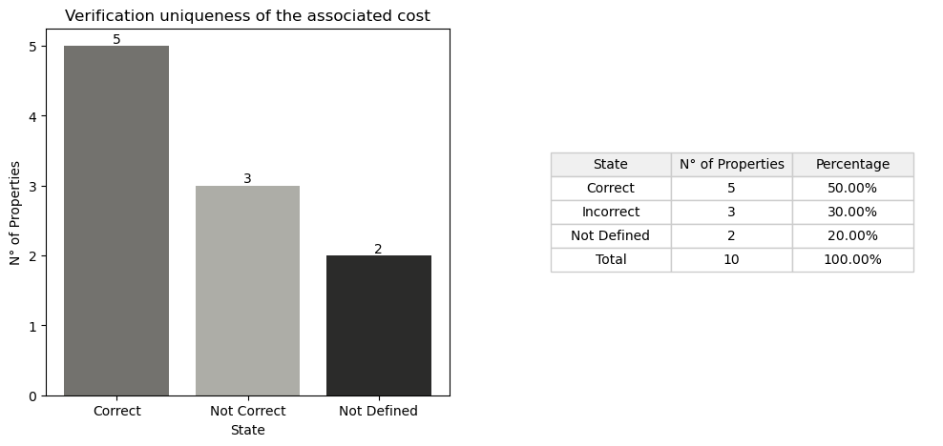

## *Detail Table*

|  |  |  |
| --- | --- | --- |
| **State** | **N° of Properties** | **Properties** |
| Correct | 5 | Entity IsExternal LoadBearing ConstructionMethod StructuralClass |
| Incorrect | 3 | TypeEnum StrengthClass ExposureClass |
| Not Defined in the obj | 2 | Compartimentation Status |
| Not Defined in the cost | 3 | FireRating ReinforcementVolumeRatio ReinforcementStrengthClass |
| Not Defined in the cost and obj | 3 | ThermalTrasmittance AcousticRating PitchAngle |

## *Detail Report*

**🔸Number of Correct Properties: 5**

Entity: ✓   
 • #14=IfcWall('2R1iaaIkD2eQphed5K5J8g',$,'Sample element of concrete wall','Sample element of concrete wall',$,$,$,$,.SOLIDWALL.)   
 • #3676=IfcWall('1sm_GUAnj8mBnFLn7Qxzzx',#21,'Muro di base:MUR_STR_CA_30_CA30:152817',$,'Muro di base:MUR_STR_CA_30_CA30',#3639,#3675,'152817',.NOTDEFINED.)   
  
IsExternal: ✓   
 • #18=IfcPropertySingleValue('IsExternal','Indication whether the element is designed for use in the exterior (TRUE) or not (FALSE). If (TRUE) it is an external element and faces the outside of the building',IfcBoolean(.T.),$)   
 • #338=IfcPropertySingleValue('IsExternal',$,IfcBoolean(.T.),$)   
  
LoadBearing: ✓   
 • #19=IfcPropertySingleValue('LoadBearing','Whether this component is carrying (YES) or not carrying (NO)',IfcBoolean(.T.),$)   
 • #615=IfcPropertySingleValue('LoadBearing',$,IfcBoolean(.T.),$)   
  
ConstructionMethod: ✓   
 • #22=IfcPropertySingleValue('ConstructionMethod','Designator for whether the concrete element is constructed on site or prefabricated. Allowed values are: In-Situ vs Precast',IfcLabel('In Situ'),$)   
 • #3687=IfcPropertySingleValue('ConstructionMethod',$,IfcLabel('In Situ'),$)   
  
StructuralClass: ✓   
 • #23=IfcPropertySingleValue('StructuralClass','The structural class defined for the concrete structure (e.g. 1)',IfcLabel('S4'),$)   
 • #3688=IfcPropertySingleValue('StructuralClass',$,IfcLabel('S4'),$)

**🔸Number of Incorrect Properties: 3**

TypeEnum: ✗   
 • #14=IfcWall('2R1iaaIkD2eQphed5K5J8g',$,'Sample element of concrete wall','Sample element of concrete wall',$,$,$,$,.SOLIDWALL.)   
 • #3676=IfcWall('1sm_GUAnj8mBnFLn7Qxzzx',#21,'Muro di base:MUR_STR_CA_30_CA30:152817',$,'Muro di base:MUR_STR_CA_30_CA30',#3639,#3675,'152817',.NOTDEFINED.)   
  
StrengthClass: ✗   
 • #24=IfcPropertySingleValue('StrengthClass','Classification of the concrete strength in accordance with the concrete design code which is applied in the project',IfcLabel('C28/35'),$)   
 • #3689=IfcPropertySingleValue('StrengthClass',$,IfcLabel('C30/37'),$)   
  
ExposureClass: ✗   
 • #25=IfcPropertySingleValue('ExposureClass','Classification of exposure to environmental conditions, usually specified in accordance with the concrete design code which is applied in the project',IfcLabel('XC1'),$)   
 • #3690=IfcPropertySingleValue('ExposureClass',$,IfcLabel('XC2'),$)

**🔸Number of Not Defined Properties in Obj: 2**

Compartimentation: ✗   
 • property not found in OBJ  
  
Status: ✗   
 • property not found in OBJ

**🔸Number of Not Defined Properties in Cost Item: 3**

FireRating: ✗   
 • property not found in COST ITEM  
  
ReinforcementVolumeRatio: ✗   
 • property not found in COST ITEM  
  
ReinforcementStrengthClass: ✗   
 • property not found in COST ITEM

**🔸Number of Not Defined Properties in Cost Item and Obj: 3**

ThermalTrasmittance: ✗   
 • property not found in OBJ and COST ITEM  
  
AcousticRating: ✗   
 • property not found in OBJ and COST ITEM  
  
PitchAngle: ✗   
 • property not found in OBJ and COST ITEM